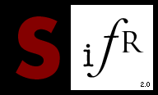



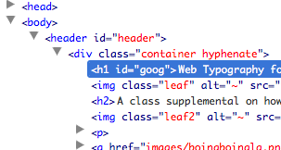

Typography for Lawyers

Jay Margalus

Terms/Definitions

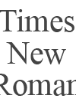

Web-safe fonts
Typefaces are normally shown on websites using fonts the visitor has on their own computer. Web-safe fonts are safe because they’re on most people’s computers. Examples would be Times New Roman, Arial, or Verdana.

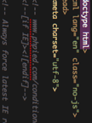

@font-face
This is a relatively new CSS construct that allows a web developer to show to a website’s visitor, dynamically, fonts that are not web-safe.



HTML Tags
The basic elements of any website, they format the elements within them. Most tags need to be closed, as well as opened. For instance, the <body> tag must be closed with </body>.

Flash
For our purposes, with font embedding, Flash files (SWFs, particularly) are used to dynamically replace text on websites.

Javascript
Another programming language that you can use in conjunction with HTML. For our purposes, it’s important to know that it’s used to embed fonts. Fonts are converted into Javascript, which is then embedded into your browser.

What To Look For

<script> tags
Script tags are normally found in the header (<head>) of any HTML. They are synonymous with Javascript, which things like sIFR and cufón rely on. If a font is embedded using Javascript, the font name will often be found between these tags.

<link> tags, @font-face
These can be used to reference CSS, which can contain @font-face elements. If a website is using @font-face, you can determine the font embedded by looking at the CSS of a website and finding the font-face references.

<object> tags, right click on element “About Adobe Flash”
Object tags are widely used to embed Flash files in a website. Another way to detect use of Flash to dynamically replace fonts is by right clicking on the text element. If the box that pops up has something like “About Adobe Flash” in it, then it’s a Flash element.

